PRACTO BUSINESS CASE STUDY AND DBMS ARCHITECTURE



DOMAIN - HEALTHCARE TECHNOLOGY (HEALTHTECH)

COMPANY - PRACTO (FOUNDED IN 2008)

DATE - 11 FEB 2026



PRODUCT DISSECTION

1. Platform Selection

1.1. Overview
Practo is India’s leading integrated healthcare platform. Unlike competitors that often focus on a single vertical (like pharmacy or diagnostics), Practo operates as a comprehensive ecosystem connecting patients, doctors, clinics, hospitals, and diagnostic centers. It functions as a full-stack HealthTech solution, bridging the gap between online discovery and offline care.

1.2. Rationale for Selection
The group selected Practo for this case study due to its immense scale and transformative impact on the Indian healthcare sector.
- Market Dominance: It serves over 30 Crore (300 Million+) patients annually and supports a network of over 1.2 Lakh verified doctors. It is widely recognized as the go-to platform for digital healthcare in India.
- Industry Impact: Practo has played a pivotal role in digitizing India’s traditionally fragmented and offline healthcare system. Its push for telemedicine—especially post-COVID-19—has democratized access to specialists, allowing patients in smaller towns to consult top doctors in metro cities.
- Relevance: The platform is a perfect subject for analysis because it operates on a dual model: a B2C Marketplace for patients and a B2B SaaS for providers. This complexity makes it a rich example of how technology integrates diverse stakeholders into a unified system.

2. Core Features & Functionalities
Practo operates as a two-sided platform, creating distinct value for its two primary user bases: Patients and Healthcare Providers.

2.1. Patient-Facing Features (B2C)
These features are designed to enhance accessibility, convenience, and transparency for users.
- Doctor Search & Discovery: A location-based search engine that allows patients to find doctors based on specialty, fees, and availability. Crucially, it provides transparency through verified patient reviews, helping users make informed decisions.
- Instant Appointment Booking: Users can view real-time doctor availability and book slots instantly, eliminating the friction of phone calls and reducing waiting times at clinics.
- Teleconsultation (Video/Chat): A secure communication layer enabling remote consultations. This ensures timely medical advice and improves accessibility for those with mobility issues or in remote locations.
- Integrated E-Pharmacy & Diagnostics: A seamless logistics network allowing users to upload prescriptions for home medicine delivery or schedule lab tests with home sample collection.
- Practo Drive (Health Locker): A digital repository for medical records. Patients can store prescriptions, reports, and bills centrally, solving the perennial problem of lost paper documents and ensuring continuity of care.
- Patient Feedback & Ratings: After consultations, patients can rate doctors and provide feedback based on their experience. This creates transparency, builds trust, and helps other users choose the right doctor. It also encourages doctors to maintain high service quality.
- Practo Plus: A subscription-based loyalty program offering unlimited online consultations, designed to increase long-term user retention.

2.2. Provider-Facing Features (B2B SaaS)
These tools digitize clinical operations, improving efficiency for doctors and hospitals.
- Practo Ray (Clinic Management): A comprehensive cloud-based software for clinics that automates appointment scheduling, billing, inventory, and digital prescriptions. It significantly reduces manual administrative work.
- Practo Insta (Hospital Management): An enterprise-grade solution for hospitals to manage complex workflows like patient admissions, operation theatre schedules, and insurance processing.
- Digital Visibility & Profile Management: Verified digital profiles help doctors build their online reputation and reach a wider audience.
- Automated Reminders: The system sends SMS and email alerts to patients, drastically reducing "no-shows" and optimizing appointment utilization.

2.3. Contribution Towards Success & User Engagement
Practo’s features are not just service offerings; they directly contribute to business growth, customer retention, and platform sustainability.
- Improved User Trust: Verified doctor profiles, transparent pricing, and patient reviews build credibility. When users trust the platform, they are more likely to book consultations and return for future services.
- Higher User Retention: Features like Practo Plus subscriptions, Health Locker (Practo Drive), and centralized records encourage patients to stay within the ecosystem instead of switching to competitors.
- Increased Booking Conversions: Real-time availability and instant appointment booking reduce friction in the booking process. The simpler the process, the higher the chances of successful bookings.
- Greater Accessibility = Larger User Base: Teleconsultation removes geographical barriers, allowing patients from Tier-2 and Tier-3 cities to access metro specialists. This significantly expands Practo’s addressable market.
- Reduced No-Shows & Operational Efficiency: Automated reminders and digital scheduling reduce missed appointments. This improves clinic utilization rates and increases revenue for doctors.

Strong Network Effect: More doctors attract more patients. More patients attract more doctors. This creates a self-reinforcing growth cycle, strengthening Practo’s market position.
- Data-Driven Personalization: Centralized digital records and transaction history allow Practo to understand user behavior. This helps in sending personalized recommendations, improving engagement and repeat usage.

3. Real-World Problems & Solutions

The Problem | Practo’s Technological Solution
Fragmented Services | Unified Ecosystem: Integrating discovery, booking, medicines, and labs into one app prevents patients from having to coordinate between disconnected providers.
Booking Friction | Real-Time Scheduling: Replaces the uncertainty of "walk-ins" and phone tag with instant confirmation and automated reminders.
Limited Access | Telemedicine: Bridges the geographical gap, giving patients in Tier-2/3 cities access to top-tier specialists without travel.
Operational Inefficiency | SaaS Automation: Ray and Insta digitize manual clinic workflows (billing, records), allowing doctors to focus on care rather than administration.
Trust Deficit | Verification System: By verifying medical credentials and hosting moderated patient reviews, the platform builds a layer of trust that was previously missing.
Poor Continuity | Health Locker: Centralizing records ensures that a patient's history travels with them, preventing medical errors due to missing information.
Practo addresses several systemic inefficiencies in the Indian healthcare infrastructure. The platform’s features map directly to these real-world challenges:

4. Business Model Analysis
Practo employs a hybrid revenue model that ensures sustainability by monetizing both sides of its marketplace.

4.1. Revenue Streams
- SaaS Subscriptions (Recurring Revenue): Doctors and hospitals pay monthly or annual subscription fees for the Practo Ray and Practo Insta software. This provides a stable financial baseline for the company.
- Transaction Commissions: The platform earns a service fee or commission on transactions facilitated through the app, including online consultations, medicine orders, and diagnostic bookings.
- Advertising (Sponsored Listings): Doctors and clinics can purchase "sponsored" slots to appear at the top of search results, functioning as a digital marketing channel.
- Consumer Subscriptions (Practo Plus): Direct revenue from patients paying for annual memberships, which drives higher engagement and customer lifetime value (CLV).

4.2. Value Proposition
- For Patients: Convenience, speed, and access to trusted healthcare information.
- For Doctors: Increased patient footfall, operational efficiency, and brand visibility.
- For the Ecosystem: Organized data and standardized pricing across a previously unorganized market.

5. Competitive Landscape
The Indian HealthTech market is highly competitive, with several major players vying for market share.

5.1. Key Competitors
- Tata 1mg: Strongest in the e-pharmacy and supply chain sector; highly competitive on medicine pricing and delivery speed.
- Apollo 24/7: Leverages the massive physical infrastructure of the Apollo Hospital network to build trust and integrate offline-online care.
- PharmEasy: Focuses aggressively on diagnostics and pharmacy services with a discount-driven strategy.
- MFine: Specializes in AI-driven, on-demand teleconsultations.

5.2. Strategic Advantage
Practo’s primary advantage is its Doctor-First DNA.
While competitors often started with products (selling medicines) and added doctors later, Practo started by building software for doctors. This has created a strong "lock-in" effect—once a clinic relies on Practo Ray for its patient records and billing, switching to a competitor is difficult. This deep integration with the supply side (doctors) is Practo's strongest defense against deep-pocketed competitors like Tata and Reliance.

SCHEMA DESIGN

1.1. Product Architecture (The Data Sources)
Before defining the database tables, it is critical to identify the ecosystem of systems that generate the data. Practo operates as an integrated network of four distinct applications feeding into a central data warehouse.

A. The Ecosystem Components
- Consumer App (Client-Side)
  - Actor: Patients (mapped to patients table).
  - Actions: Search, Book Appointments, Upload Records, Make Payments.
- Practo Ray (Provider SaaS)
  - Actor: Doctors & Clinics (mapped to doctors & clinics tables).
  - Actions: Manage Calendar, Digital Prescriptions, Billing.
- Practo Insta (Hospital HMS)
  - Actor: Enterprise Hospitals.
  - Actions: Bed management, In-Patient Department (IPD) workflows, Insurance processing.
- Admin/Operations Panel
  - Actor: Practo Internal Team.
  - Actions: Verification of doctors, Content moderation, Prime subscription management.

B. High-Level Data Flow
- Input: Users interact with the Frontend interfaces (App/Web).
- Processing: API Gateway routes requests to specific Microservices (e.g., Search Service, Booking Service).
- Storage: Validated data is committed to the Primary Database (OLTP) defined in the schema below.

1.2. Conceptual Data Model
This section defines the high-level landscape of the database, categorizing Entities and Verbs.

The Entities
- Users: The central identity table (users). A single login that links to either a Patient or Doctor profile.
- Profiles: The specific roles assumed by a user.
  - Patient Profile (patients): Demographics, medical history, location.
  - Doctor Profile (doctors): Qualifications, experience, verification status.
- Supply: The physical and temporal availability of care.
  - Clinics (clinics): The physical location.
  - Availability (doctor_availability): The junction where a Doctor meets a Clinic.
- Transactions: The core business events.
  - Appointments (appointments): The booking event.
  - Financials (payments, subscriptions): The monetary exchange.
- Clinical Data: The outcome of the interaction.
  - Records (medical_records): Prescriptions, reports, and notes.

1.3. Detailed Schema Specification
This blueprint details the table structures, optimized for data analysis and business intelligence.

1. Users
Attribute | Type | Description
user_id | UUID (PK) | Unique identifier for account
created_at | TIMESTAMP | Account creation time
is_active | BOOLEAN | Active flag

2. Patients
Attribute | Type | Description
patient_id | UUID (PK) | Unique patient profile ID
user_id | UUID (FK) | Links to users table (unique)
dob | DATE | Date of birth
gender | VARCHAR(20) | Gender
city | VARCHAR(100) | City for location-based analysis
zip_code | INT | City Postal code
country | ENUM | Country

3. Doctors
Attribute | Type | Description
doctor_id | UUID (PK) | Unique doctor profile ID
user_id | UUID (FK) | Links to users table (unique)
specialization | VARCHAR(100) | Primary medical field
experience_years | INT | Years of professional experience
is_verified | BOOLEAN | Doctor verification flag

4. Clinics
Attribute | Type | Description
clinic_id | UUID (PK) | Unique clinic ID
name | VARCHAR(100) | Clinic name
geo_lat | DECIMAL(9,6) | Latitude for geolocation
geo_long | DECIMAL(9,6) | Longitude for geolocation
tier | VARCHAR(20) | Clinic tier / category
country | ENUM | Country

5. Doctor_Availability
Attribute | Type | Description
availability_id | UUID (PK) | Unique availability slot ID
doctor_id | UUID (FK) | Links to doctors table
clinic_id | UUID | Links to clinics table
consultation_fee | DECIMAL(10,2) | Fee per consultation
slots_per_hour | INT | Number of slots per hour

6. Appointments
Attribute | Type | Description
appointment_id | UUID (PK) | Unique appointment ID
patient_id | UUID (FK) | Links to patients table
availability_id | UUID (FK) | Links to doctor_availability table
status | ENUM | Appointment status (booked, completed, cancelled)
booking_time | TIMESTAMP | When appointment was booked
slot_time | TIMESTAMP | Scheduled appointment time
is_prime_booking | BOOLEAN | Flag for prime subscriptions

7. Payments
Attribute | Type | Description
payment_id | UUID (PK) | Unique payment ID
appointment_id | UUID (FK) | Links to appointments table
amount_paid | DECIMAL(10,2) | Amount paid
payment_mode | VARCHAR(50) | Payment method

8. Medical_Records
Attribute | Type | Description
record_id | UUID (PK) | Unique medical record ID
appointment_id | UUID (FK) | Links to appointments table
type | VARCHAR(50) | Type of record (prescription, lab report)
file_url | TEXT | File location URL
tags_json | JSON | Tags for categorization

9. Subscriptions
Attribute | Type | Description
subscription_id | UUID (PK) | Unique subscription ID
patient_id | UUID (FK) | Links to patients table
plan_type | VARCHAR(50) | Plan type (basic, premium, prime)
start_date | DATE | Subscription start date
end_date | DATE | Subscription end date
status | VARCHAR(20) | Active / inactive subscription status

The Relationship
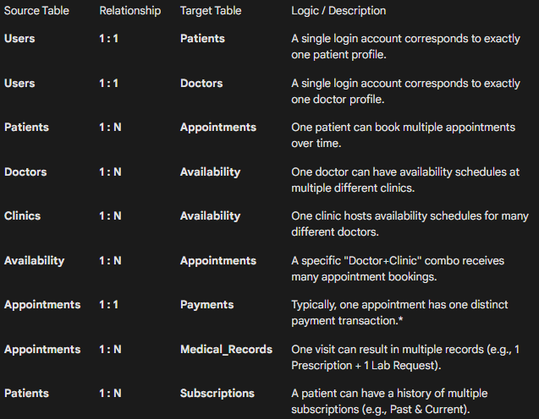

Entity Relationship Diagram

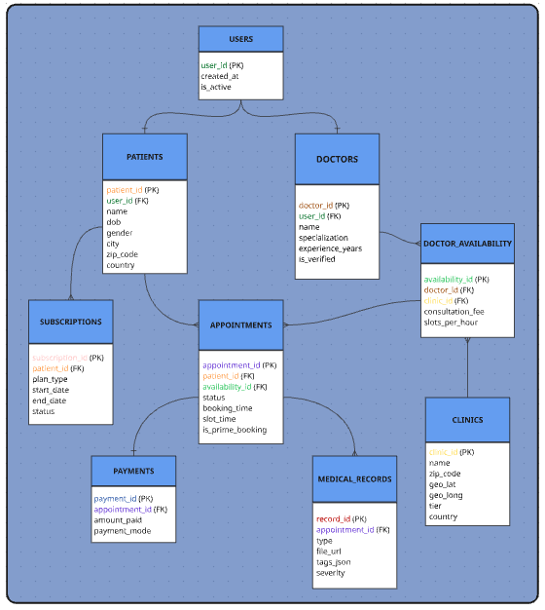

Revenue and Profit Growth Strategies
CASE STUDY

How can we increase the profit of practo by at least 25%?

To increase the profit of the platform by at least 25%, a structured inside-out methodology is followed. In this approach, the company first analyses its internal operations, costs, and performance before focusing on revenue expansion and market growth. By improving efficiency, reducing unnecessary expenses, and strengthening customer engagement using data-driven insights, sustainable profit growth can be achieved.
The following sections explain the analytical approach used to evaluate the current situation and define strategies for improving profitability.
I. Analysing Practo’s Current Status
Category | Details
Current Financial Analysis | Collect Financial Data
 | Revenue: Practo generates revenue through multiple channels: SaaS software for doctors, appointment commissions, teleconsultations, diagnostics & pharmacy orders, sponsored doctor listings, and patient subscriptions.
 | Expenses: Major costs include employee salaries, cloud infrastructure for video consultations, marketing acquisition cost, verification operations, and payment gateway charges.
 | Analyse Current Profit
 | Profit Calculation: Profit = Total Revenue − Total Operational Expenses.
 | Trend Analysis: Post-COVID growth increased consultations but also raised marketing and infrastructure costs. Profitability now depends on improving efficiency rather than only increasing traffic.
Sources of Revenue | SaaS Subscriptions(~35%): Recurring payments from clinics using practice-management software. Stable and predictable revenue.
 | Appointment Commissions(~20%): Percentage earned per booked appointment. Depends on user traffic.
 | Teleconsultation(~15%): High-margin online consultations that expanded rapidly after COVID.
 | Diagnostics & Pharmacy(~18%): Additional services attached after doctor consultation.
 | Sponsored Listings(~7%): Doctors pay for higher visibility in search results.
 | Practo Plus Subscription(~5%): Patient membership model encouraging repeat usage.
Sources of Expenses | Salaries(~30%): Engineering, sales, and support teams.
 | Cloud Infrastructure(~28%): Video consultation servers and storage.
 | Marketing(~25%): User acquisition campaigns.
 | Operations & Support(~10%): Verification and customer support.
 | Payment Processing(~7%): Gateway transaction charges.
Customer Acquisition & Retention | Acquisition Channels: Organic search, paid ads, referrals, partnerships, hospital collaborations.
 | Channel Effectiveness: Compare CAC (Customer Acquisition Cost) vs CLV (Customer lifetime value) to determine profitable channels.
 | Retention Rate: Measure repeat consultation frequency and subscription renewal rates.
 | Churn Analysis: Identify drop-offs after first consultation or subscription expiry.
 | Customer Behaviour Analysis: Study booking patterns, preferred specialties, and seasonal demand spikes.

By analysing the current status of Practo’s, including its financial data, revenue sources, expenses, and customer acquisition channels we can develop a comprehensive strategy to increase the company's profit by 25%. Focusing on optimizing expenses, enhancing revenue streams, and improving customer satisfaction and retention will ensure sustainable growth and profitability for Practo’s.
Using data-driven insights at each step will lead to more effective and strategic decision-making.

II. Focus Areas for Increasing Practo’s Profit by 25%
To achieve 25% profit growth, Practo must focus on:
Category | Focus Area | Measures
Internal Management (~8% Profit Impact) | Operational Efficiency (~6%) | Smart Scheduling: Predict peak demand and allocate doctor slots efficiently to reduce idle time.  Cloud Optimization: Adjust server usage dynamically to reduce unnecessary computing cost.  No-Show Reduction: Automated reminders and rescheduling suggestions to avoid revenue loss.
 | Employee Productivity (~2%) | Performance Tracking: Monitor doctor onboarding success rate and subscription renewals.  Automation: Reduce manual verification using AI document validation.
Revenue Enhancement  (~8% Impact) | Cross-Selling Services  (~ 4%) | After Consultation Suggestions: Recommend lab tests or medicines immediately after doctor visit.  Care Bundles: Combine consultation + follow-up + tests into one package.
 | Premium Monetisation  (~ 4%) | Featured Doctor Plans: Multiple paid visibility tiers for doctors.  Dynamic Commission: Higher platform fee during peak demand slots.
Product Strategy (~4% Impact) | Chronic Care Programs  (~ 2%) | Subscription plans for diabetes, skin care, and heart conditions requiring repeated visits.
 | Premium Teleconsultation  (~ 2%) | Faster appointments with highly rated doctors at higher platform margin.
Market Expansion (~3% Impact) | Tier-2 & Tier-3 Expansion (~2%) | Promote telemedicine where doctor availability is limited.
 | Corporate Plans  (~ 1%) | Offer healthcare subscription packages to company employees.
Post-Sales & Retention  (~2% Impact) | Loyalty & Engagement  (~ 2%) | Follow-up Reminders: Encourage repeat consultations.  Health Rewards Wallet: Cashback for frequent users.  Churn Alerts: Identify inactive users and send personalised offers.
Branding & Marketing (~1%) | Referral Programs | Incentivize users to bring new patients.
 | Doctor Success Stories | Highlight verified specialists to build trust.
 | SEO & Content Marketing | Publish healthcare blogs to increase organic traffic.

By focusing on internal management, product strategy, market expansion, post-sales management, and branding, Practo’s can strategically enhance its profitability by 25%. Each focus area should be approached with data-driven insights to ensure that initiatives are effective and aligned with customer needs and market demands. Implementing these strategies will not only increase profitability but also strengthen Practo’s position in the competitive market.

III. Defining Strategies
Category | Details
Optimise Expenses | Cost Reduction: Reduce operational expenses by renegotiating vendor contracts, optimizing cloud infrastructure usage, and minimizing unnecessary marketing expenditure.
 | Efficiency Improvements: Implement AI-driven scheduling systems to reduce appointment gaps and lower idle capacity for doctors.
 | Technology Optimization: Consolidate redundant software tools and improve automation in billing, reminders, and support.
Enhance Revenue Streams | Upselling and Cross-Selling: Recommend lab tests and pharmacy purchases immediately after consultation booking or completion.
 | New Revenue Streams: Introduce chronic care subscription plans and preventive health packages.
 | Pricing Strategies: Apply dynamic pricing for peak consultation hours and premium specialist categories.
 | Sponsored Visibility: Offer tier-based promotional packages for doctors to improve search ranking.
Improve Customer Satisfaction and Retention | Personalised Experiences: Use patient history and booking patterns to recommend relevant specialists and follow-up consultations.
 | Loyalty Programs: Provide reward points or discounts for repeat bookings and long-term subscriptions.
 | Customer Feedback System: Strengthen post-consultation review collection and act on low-rating trends.
 | Retention Automation: Send AI-driven reminders for follow-ups, prescription refills, and annual health checkups.
Expand Market Presence | Geographic Expansion: Expand telemedicine penetration in Tier-2 and Tier-3 cities.
 | Corporate Partnerships: Offer bundled healthcare packages to companies for employee wellness programs.
 | Brand Building: Invest in SEO, health awareness campaigns, and referral incentives.
Digital & Data Strategy | Predictive Analytics: Use data models to forecast demand spikes and optimize doctor availability.
 | Churn Prediction: Identify users at risk of dropping off and trigger targeted retention campaigns.
 | Performance Dashboards: Implement KPI dashboards for revenue, retention, and conversion tracking.

By adopting an inside-out methodology, Practo’s can systematically reduce inefficiencies, enhance high-margin revenue streams, and improve long-term customer retention. Focusing first on cost optimization, then strengthening customer engagement, and finally expanding revenue channels provides a structured roadmap to achieve a sustainable 25% increase in profitability. Data-driven decision-making at every stage ensures measurable and scalable growth.

Guesstimate
Question 1: Estimate the potential annual cost savings for a hospital if it reduces its readmission rate by 10%.

Step | Details | Calculation
Hospital Size | Assume a 300-bed hospital
Average Occupancy | 70% occupancy | 300 × 0.7 = 210 occupied beds/day
Average Length of Stay | 5 days per patient
Annual Patients (Discharges) | Patients treated per year | (210 × 365) / 5 ≈ 15,300 patients
Current Readmission Rate | Assume 15% readmission | 15,300 × 0.15 ≈ 2,295 readmissions
Reduction in Readmissions | Reduce by 10% | 2,295 × 0.10 ≈ 230 avoided readmissions
Cost per Readmission | Assume $10,000 per case
Annual Cost Savings | 230 × $10,000 | $2.3 Million
Final Estimate:
Reducing hospital readmission rate by 10% can save approximately $2 – $2.5 Million annually for a 300-bed hospital

Question 2: Estimate the potential annual revenue generated by a hospital if 20% of its consultations are shifted to telemedicine.
Step | Details | Calculation
Total Annual Consultations | Assume 50 doctors | 20 patients/day × 300 days × 50 = 300,000 consultations
Shift to Telemedicine | 20% shift | 300,000 × 0.20 = 60,000 teleconsultations
Average Tele consult Fee | Assume $60 per consultation | 60,000 × $60 | = $3.6 Million
Operational Savings | Telemedicine reduces infra cost by $15 per visit | 60,000 × $15 = $900,000
Total Financial Impact | Revenue + Savings | ≈ $4.5 Million
Final Estimate:
Shifting 20% consultations to telemedicine could generate approximately $4–5 Million annual impact.

Question 3: Estimate the annual market size for a diabetes medical device in the United States.
Step | Details | Calculation
US Population | 330 Million
Diabetes Prevalence | Assume 10% population | 330M × 0.10 = 33M patients
Target Segment | Assume 40% require monitoring device | 33M × 0.40 = 13M users
Annual Device Cost | $500 per year
Market Size | 13M × $500 | $6.5 Billion
Final Estimate:
The potential annual market size ≈ $6–7 billion.

Question 4: Estimate additional annual revenue for a clinic implementing preventive care programs.
Step | Details | Calculation
Clinic Patient Base | 10,000 active patients annually
Adoption Rate | Assume 30% opt for preventive plan | 10,000 × 0.30 = 3,000 patients
Annual Preventive Plan Cost | $200 per patient
Revenue | 3,000 × $200 | $600,000
Cross-Selling Effect | Assume 10% additional diagnostics | $600,000 × 0.10 = $60,000
Total Additional Revenue |  | $660,000
Final Estimate:
Preventive programs could generate $600K–700K additional annual revenue.
Question 5: Estimate annual cost savings from optimizing hospital supply chain management.
Step | Details | Calculation
Annual Hospital Budget | Assume $100 Million
Supply Chain Portion | Assume 30% of budget | $100M × 0.30 = $30M
Optimization Efficiency | Assume 8% cost reduction | $30M × 0.08 = $2.4M
Waste Reduction | Additional 2% saving | $30M × 0.02 = $600K
Total Savings |  | $3 Million
Final Estimate:
Optimizing supply chain management could save approximately $3 Million annually.
Cohort Analysis & A/B Testing
Question 1: How would you conduct a cohort retention analysis to track the monthly usage of the app by patients who signed up in different months? What metrics would you focus on?
Step 1: First we need to collect patient’s activity data

Patient ID | Sign-Up Date | First Activity Date | Health Condition | Activity Dates
1 | 2024-01-05 | 2024-01-05 | Diabetes | Jan 05, Feb 06, Mar 04
2 | 2024-01-18 | 2024-01-19 | Hypertension | Jan 19, Feb 20
3 | 2024-02-02 | 2024-02-03 | Diabetes | Feb 03, Mar 02, Apr 02
4 | 2024-03-10 | 2024-03-11 | Hypertension | Mar 11
5 | 2024-03-21 | 2024-03-21 | Diabetes | Mar 21, Apr 18

Active patient is the one who books a slot_time , has booking_time for first session and follow up’s.
Step 2: Define Cohorts - we will divide patients into monthly groups based on their signup date.
Cohort | Patient IDs | Cohort Start Date | Cohort End Date
Jan 2024 | 1,2 | 2024-01-01 | 2024-01-31
Feb 2024 | 3 | 2024-02-01 | 2024-02-29
Mar 2024 | 4,5 | 2024-03-01 | 2024-03-31

Step 3: Track patient’s monthly retention ( how many patients were still active end of the month)
Metric | Jan Cohort | Feb Cohort | Mar Cohort
Number of Patients | 2 | 1 | 2
Patient’s Active in Month 1 | 2 | 1 | 2
Patient’s Active in Month 2 | 2 | 1 | 1
Patient’s Active in Month 3 | 1 | 1 | 1
Retention in Month 1 | 100% | 100% | 100%
Retention in Month 2 | 100% | 100% | 50%
Retention in Month 3 | 50% | 100% | 50%

Step 4: Analyse Patterns
Pattern | Jan Cohort | Feb Cohort | Mar Cohort
Engagement Trend | Gradual drop | Stable | Early drop
Usage Behaviour | Habit forming | Chronic patient | Trial usage
Drop-off Month | Month 3 | No drop | Month 2
Monitoring Consistency | Medium | High | Low

Step 5: Actionable Insights
Insight | Action
For Drop After Month-2 | Send personalised medication reminders
Trial Users Leaving Early | Add onboarding health goal setup
To Keep Chronic Patients Active Longer | Provide follow up notifications by doctor
For Declining Engagement | Introduce streak rewards & health score

Summary Table
Process Step | Details
Data Collection | Collected signup date, condition type, and activity logs
Define Cohorts | Grouped patients by signup month
Track Metrics | Measured monthly retention and engagement
Analyse Patterns | Identified drop-off after second month
Actionable Insights | Suggested reminders and follow-ups

Question 2: If you notice that retention rates drop significantly after the second month, what might be some reasons for the drop-off, and how could the company improve retention?
Reasons for Drop-Off & Improvements
Reason | Improvement
Patients feel better | Send preventive care alerts
Manual data entry effort | Integrate wearable devices
No doctor interaction | Monthly doctor follow-up reminders
Low perceived value | Provide personalised health insights
No motivation | Reward & streak system

Weekly Patient Retention Dataset

Cohort | New Patients | Week 1 | Week 2 | Week 3 | Week 4 | Week 5 | Week 6 | Week 7 | Week 8 | Week 9
Jan 01, 2024 | 120 | 70 | 60 | 52 | 46 | 40 | 35 | 30 | 26 | 22
Jan 08, 2024 | 150 | 82 | 72 | 63 | 55 | 48 | 42 | 36 | 30 | 26
Jan 15, 2024 | 140 | 78 | 68 | 59 | 52 | 45 | 39 | 34 | 29 | 25
Jan 22, 2024 | 130 | 72 | 62 | 54 | 48 | 41 | 36 | 31 | 27 | 23
Jan 29, 2024 | 160 | 88 | 76 | 66 | 58 | 50 | 44 | 38 | 33 | 29
Feb 05, 2024 | 180 | 95 | 82 | 72 | 63 | 55 | 48 | 42 | 37 | 32
Feb 12, 2024 | 150 | 86 | 74 | 65 | 57 | 49 | 43 | 37 | 32 | 28
Feb 19, 2024 | 170 | 92 | 79 | 69 | 60 | 52 | 45 | 39 | 34 | 30
Feb 26, 2024 | 160 | 88 | 75 | 65 | 56 | 49 | 42 | 36 | 31 | 27
Mar 04, 2024 | 155 | 85 | 73 | 63 | 55 | 48 | 41 | 35 | 30 | 26

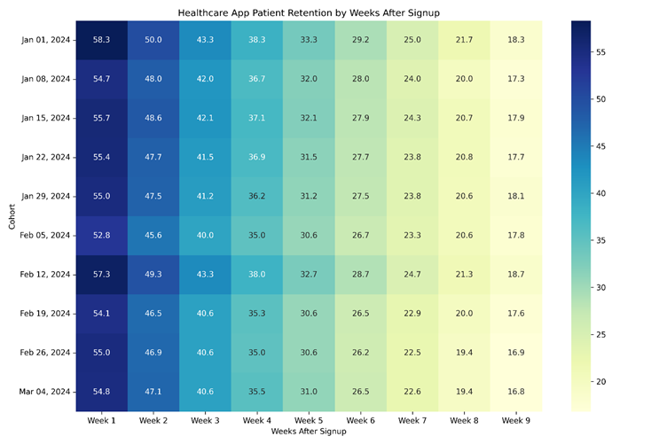
This heatmap represents patient retention behaviour in a chronic disease management application. The retention rate is highest in the first week after registration because patients actively explore the app after diagnosis. A noticeable drop occurs after Week-3, indicating reduced motivation once symptoms stabilize. A small percentage of users continue long-term usage, representing chronic patients who require continuous monitoring.
This analysis helps identify engagement decay and highlights the importance of reminders, follow-ups, and personalised health insights to improve long-term patient retention.

A/B Testing (Healthcare Chronic Care App)
Question 1: Design an A/B test to evaluate whether personalised health insights lead to higher patient engagement compared to general health advice. What metrics would you track to determine success?

Scenario
A healthcare company wants to test whether personalised health insights improve patient engagement in its chronic disease management app.
Version A provides general health advice, while Version B provides personalised insights based on medical history and test reports.

Hypothesis
Providing personalised health insights will increase patient engagement and adherence compared to general health advice.

Steps:
1. Create Variants:
i. Version A (Control): General health tips such as “Drink water, exercise daily, eat healthy food.”
ii. Version B (Variant): Personalised insights such as “Your BP increased 8% this week. Walk 20 minutes after dinner.”
2. Random Assignment
Split patients into two equal groups, with one group seeing Version A and the other seeing Version B.
3. Data Collection
Track patient engagement metrics over 30 days:
- App logins
- Vitals entries (BP/Sugar)
- Medication adherence
- Doctor consultations
4. Analysis
Compare engagement and adherence rates between the two versions using statistical comparison.
5. Conclusion
Determine which version increases engagement and implement that version.
Summary
Variant | Users | Active Patients | Engagement Rate
Version A (Control) | 5,000 | 1,900 | 38%
Version B (Variant) | 5,000 | 2,600 | 52%

Result
Version B shows a 37% increase in engagement compared to Version A.
Conclusion
Implement Version B (Personalised Health Insights) to improve patient engagement and retention.
Question 2: If Version B (personalised insights) leads to higher engagement but also results in more support requests from patients seeking clarification on their health insights, how would you interpret this outcome, and what recommendations would you give?

Higher support requests indicate patients are actively paying attention to their health data but need help understanding medical insights.
This is a positive signal of trust and deeper engagement, not a negative outcome.

Recommendations
- Simplify medical language in insights
- Add “Explain this result” button
- Provide AI chatbot for instant clarification
- Add educational health tips/videos
- Provide doctor-verified explanations

Results and Deliverables of A/B Testing
A/B testing helps identify which feature improves patient behaviour and retention.
By continuously refining features based on data, healthcare platforms can increase adherence and improve health outcomes.

Conversion Rate Optimization (CRO)
CRO in healthcare apps focuses on converting registered patients into regularly active patients.
Even if many users install the app, success depends on how many consistently track their health and follow treatment plans.
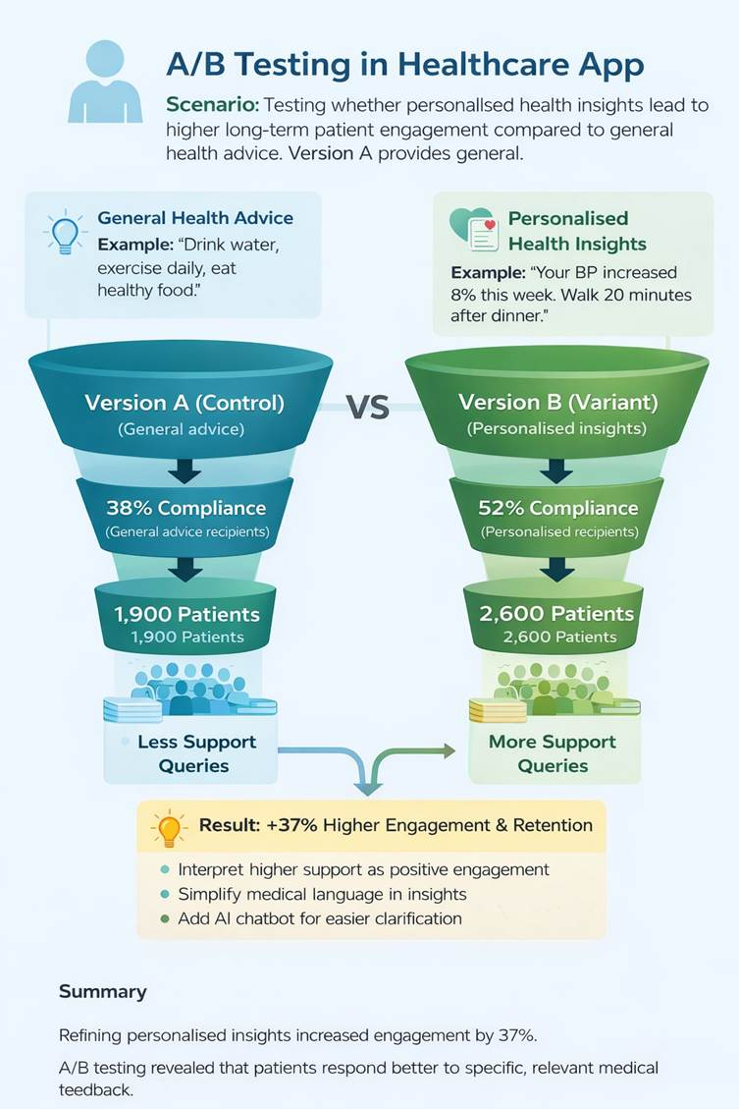

Summary
This A/B test demonstrates that personalised health insights significantly improve patient engagement, adherence, and retention in a chronic disease management application. Although personalised insights generated more support queries, this indicates higher patient involvement and trust rather than a negative outcome. Patients showed interest in understanding their health data but required clearer interpretation.
Therefore, instead of removing the feature, the platform should simplify medical explanations, introduce automated guidance such as AI chat assistance, and provide educational support. By refining communication while keeping personalisation, the healthcare app can improve patient outcomes, reduce manual support effort, and strengthen long-term user retention.

DBMS & Data Architecture

ACID Properties:
Q: A patient’s prescription update fails midway due to a power outage. How would you ensure that the database remains consistent and no partial updates occur?

A:
Atomicity: If Doctor changes medicine + dosage & System crashes halfway. Result → No changes saved (prevents half updates).
Consistency: Prescription must link to a valid patient ID. Or else the system will reject updates if a patient does not exist.
Isolation: Doctor A updates prescription. Doctor B views the patient record at the same time, Doctor B only sees final committed data, not half changes.
Durability: Practo databases use logs and storage backups to protect data.

Q: Two nurses try to update the same patient’s medical record simultaneously. How would you prevent conflicting updates?

A:
Isolation: Use Isolation property of transactions & Apply row-level locking(temporarily) on the patient record. Make the second user wait until the first finishes which can prevent overwriting and conflicting data.

Indexing:
Q: The hospital’s appointment database is queried thousands of times daily by doctor ID and patient name. How would you speed up these searches?

A:
To speed up frequent appointment searches, Practo would create indexes on high-usage columns such as doctor_id and patient_name
If queries often filter by both fields, a composite index on (doctor_id, patient_name) would further improve performance.
CREATE INDEX idx_doc_patient
ON appointments (doctor_id, patient_name);

Q: The patient lab results table is growing large and slowing down queries. How can indexing improve retrieval performance without affecting update operations too much?

A:
- Use B-Tree indexes on frequently queried columns such as patient_id and test_date.
- Composite indexes can optimize common search patterns while keeping updates efficient.
- Avoid excessive indexing and focus only on high-frequency query fields to balance retrieval speed.

Partitioning:
Q: The hospital stores years of electronic health records (EHR). How would you design the database so older data can be queried separately or archived efficiently?

A:
In healthcare EHR storage, you should design the database using date-based partitions.
- Partition the table using slot_time.
- Allow the older medical records to be archived separately while improving query performance

Q: You need to maintain compliance with regional health data laws, which require data to stay within the same country. How can partitioning help?

A:
- Practo Healthcare can implement geo-partitioning by splitting the EHR table based on country_code (India, UAE, Singapore).
- Each region stores patient data in its own partition, ensuring compliance with local healthcare data laws

Sharding:
Q: A healthcare startup scales rapidly across continents. How would you use sharding to handle increasing patient registration and appointment data volume?

A:
Meaning:
Split one large database into multiple smaller databases (shards).
Example:
- Patient registers in Mumbai
→ stored in Shard_India
- Appointment booked in Dubai
→ stored in Shard_UAE
Use region-based sharding to ensure legal compliance and faster local access, and optionally hash patient IDs to distribute load evenly.

Q: You’ve sharded patient data by country, but now doctors need global analytics on disease trends. What challenges might this create?

A:
Patient data is split across multiple country shards. The system must:
- Query India shard
- Query UAE shard
- Query EU shard
- Merge results
Sharding by country improves scalability and compliance, but global analytics becomes harder because queries must run across multiple shards. This introduces challenges such as cross-shard joins, complex aggregations, increased latency, and data consistency issues.

Normalization and Denormalization:
Q: You're designing a database for patients, doctors, and departments(specialization). How would normalization help avoid data duplication and inconsistency?
A:
Normalization (specifically Third Normal Form) involves organizing data into separate, distinct tables to minimize redundancy.
- Avoiding Duplication: Instead of repeating the full department name (e.g., "Cardiology") or specialization details in every single doctor's record, you create a dedicated reference table (e.g., Departments or Specializations) and link it using a Foreign Key ID.
- Ensuring Consistency: This prevents data anomalies. If a department name needs to be updated (e.g., changing "Paediatrics" to "Pediatrics"), it only needs to be changed in one central record rather than updating thousands of individual doctor profiles.
Q: For faster report generation on hospital admissions, would you prefer a normalized or denormalized structure? Why?
A:
A denormalized structure is preferred for reporting and analytics.
- Reduced Joins: Normalized databases require joining multiple tables (Patients + Admissions + Doctors + Wards) to generate a report, which is computationally expensive. Denormalization combines these into a single "wide" table, eliminating join overhead.
- Read Performance: Reporting focuses on reading large volumes of aggregated data. As seen in Data Warehousing strategies, storing pre-calculated aggregates (like total admissions per month) allows leadership to generate dashboards instantly without scanning millions of individual transaction records.

Data Lakes vs. Data Warehouses
Q: You collect structured EMR data, medical images, and unstructured physician notes. Where would each type of data be stored?
A:
Data Lake : Medical images, Voice recordings, Doctor text notes, &Chat messages
Why? It can store any format & Good for AI and machine learning.

Data Warehouse: Disease trends, Patient visit counts, & Appointment statistics
Why? Doctors and managers use this for Dashboards & Global health analysis

Q: The hospital’s leadership wants weekly dashboards on patient outcomes, readmission rates, and costs. How would a data warehouse help?

A:
In Practo, Data comes from many places: Appointments, EMR records, & Billing systems. Data warehouse allows OLAP(Online Analytical Processing) analysis, so leadership can see Outcomes by week, Readmissions by city, Costs by hospital or doctor.
Instead of reading millions of raw records, the warehouse stores aggregated data like:
Total patients per week, Average treatment cost, Number of readmissions
Operational databases focus on current activity, but a data warehouse stores years of history. Leaders/Manager can answer: Are readmissions increasing? Are treatment costs going up? Are patient outcomes improving?

Data Ingestion and Pipelines
Q: You need to collect real-time patient vitals from IoT devices (heart monitors, glucose sensors). What data ingestion strategy would you use?
A:
Patients use IoT devices like: Heart rate monitors, Glucose sensors, Blood pressure devices.
These devices send data every few seconds, so Practo would use a streaming data ingestion strategy where IoT devices continuously send patient vitals to a real-time pipeline. The streaming layer processes incoming data instantly, triggers alerts if vitals are abnormal, and stores raw data in a data lake while sending structured metrics to a data warehouse for analytics dashboards.

Q: The lab sends test result files once every evening. How would you design the ingestion pipeline for this batch data?
A:
External lab sends test result files once daily (evening).Files may include:
Blood test results, Diagnostic reports, Patient IDs, & Test values. Since data comes at fixed times.
Practo would design a batch ingestion pipeline triggered by an ETL scheduler that runs every evening when lab files arrive. The pipeline extracts the files, validates and transforms lab results, stores raw data in the data lake, and loads clean structured records into the data warehouse so doctors can view updated reports in dashboards the next day.

ETL (Extract, Transform, Load)
Q: You’re integrating patient data from multiple clinics into a unified database. How would you handle differences in formats and ensure consistency?
A

Extract: Collect patient data from multiple clinic systems.

Transform: Map different field names to a standard schema then clean duplicate patient records.

Load: Load cleaned and consistent data into a unified data warehouse.

Q: If your ETL process fails after partially loading new lab data, how would you ensure database consistency and prevent duplication?
A:

Use Checkpointing: Save progress after each successful step. If ETL fails, restart from the last checkpoint instead of reloading everything.

Make the Pipeline Idempotent: Use idempotent loading using unique keys to prevent duplicates.

Use Transactions & Rollback: Load data inside a database transaction.If any step fails; Roll back all partial inserts which ensures the database stays consistent.

Additional DBMS Topics:
Q: How would you manage historical updates to patient diagnoses or medications while preserving older records for legal compliance?
A:
To ensure data integrity and legal compliance (e.g., HIPAA or local regulations), the database should implement System-Versioned Temporal Tables or a dedicated Audit Trail mechanism.
- Mechanism: Instead of overwriting existing records during an update, the system inserts a new row version with a valid_from and valid_to timestamp.
- Outcome: The current application view shows only the latest diagnosis, while the history table retains an immutable log of all previous states. This allows auditors to reconstruct the patient's medical record exactly as it existed at any specific point in the past.
Q: The analytics team needs quick access to hospital occupancy data across departments. How could you optimize database performance?
A:
Optimizing for read-heavy analytics without impacting transactional write performance requires Materialized Views and Indexing.
- Materialized Views: Pre-calculate complex aggregations (e.g., COUNT(active_patients) GROUP BY specialization) and store them physically. These views can be refreshed periodically (e.g., every 15 minutes), allowing the analytics team to query instant snapshots without scanning the entire admission log table.
- Indexing: Implement composite indexes on high-traffic columns such as specialization and status to speed up real-time filtering.
Q: How would you design a backup and recovery plan to ensure no patient data is lost due to a system crash?
A:
A robust healthcare disaster recovery plan requires a multi-layered approach focusing on low Recovery Point Objective (RPO) and Recovery Time Objective (RTO).
- Point-in-Time Recovery (PITR): Enable continuous archiving of Write-Ahead Logs (WAL). If a crash occurs, the database can be replayed to the exact second before the failure.
- Geographic Redundancy: Perform daily full snapshots and frequent incremental backups, storing them in a geographically separate cloud storage region (e.g., distinct AWS S3 regions) to protect against data center outages.
- High Availability: Maintain a synchronous standby replica that can automatically promote to primary (failover) in the event of hardware failure.
Q: You're analyzing prescription data to detect potential fraud or over-prescription patterns. How would your DBMS architecture support such large-scale analysis?
A:
Fraud detection involves complex queries over massive datasets, which should be decoupled from the live operational database (OLTP) to avoid slowing down clinical workflows.
- OLAP Separation: Offload prescription records via ETL pipelines to a Data Warehouse (e.g., Snowflake, Redshift) designed for Online Analytical Processing (OLAP).
- Columnar Storage: Use columnar storage formats to rapidly aggregate millions of prescription records by doctor, drug type, or dosage.
- Pattern Detection: Run SQL window functions or integrate Machine Learning models within the warehouse to identify statistical anomalies (e.g., a doctor prescribing 3x the standard deviation of a specific narcotic).

